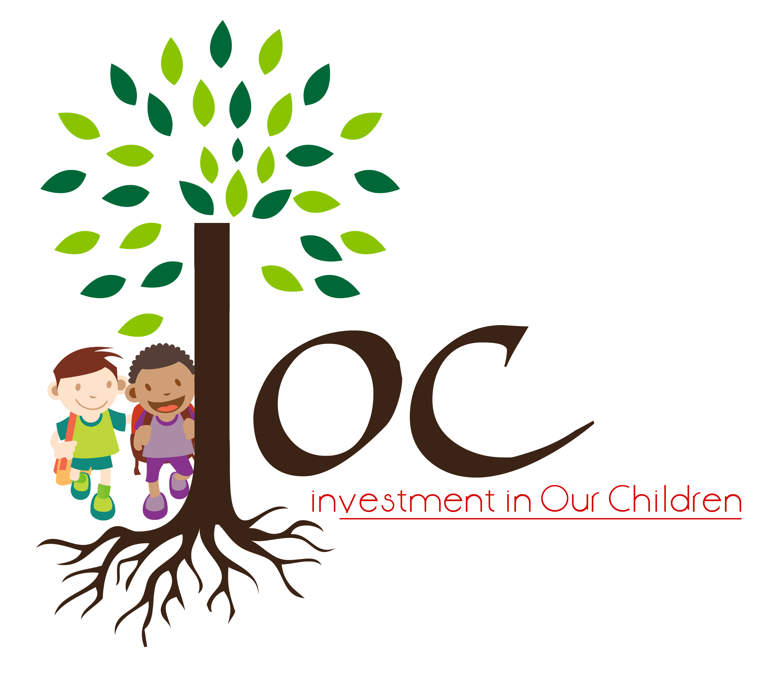

Investment in our Children Ltd
83 Colfe Road
London, SE23 2EX
Email- info@ioc-uk.org

What we Offer:

IOC shares the view that all Individuals have the right to a home and an environment which is free from abuse and exploitation in order to fulfil their full potentials. Therefore, IOC have teamed up, in providing support packages for vulnerable families who have no recourse to public funds.

This support service includes housing with support to vulnerable women and their children coupled with advocacy and emotional support for victims who have suffered from all kinds of domestic abuse.

IOC aims to provide high standards of accommodation and living to these families and where necessary offer the appropriate level of support to the families in transitioning to future independence.

To ensure we consider the best interest of our families, we work closely with partner agencies and organisations already involved in the families lives.

Our Values and Objectives:

- Challenging Inequalities
- Treating families with respect and dignity
- Enabling people to fulfil their potential
- Embracing diversity
- Empowering families

Our Mission:

IOC aims to provide a safe haven for families which is free from exploitation, discrimination and objectification.

Who Are We:

IOC is an independent organisation working across London with vulnerable families who are susceptible to exploitation in our communities. IOC has a strong, diverse and experienced workforce offering a life changing services.

IOC offers a fair and equitable service, we are an anti discriminatory and anti oppression organisation. We embrace diversity and are an equal opportunity service provider.

What We Do:

IOC is a highly specialist organisation that provides accommodation and related support services for vulnerable families with no recourse to public funds who are known to Children Services department in the United Kingdom.

Our Services Are:

- Accommodation with support for victims of trafficking and domestic abuse
- Weekly key working session with emotional support and advice
- Advocacy
- Financial Management and Budgeting skills
- Workshop and therapeutic group activities
- Self esteem building and domestic violence awareness
- Weekly progress report on functioning
- Wishes and feeling sessions with the children

Our Support Package includes:

- Life skills – equipping families with basic living skills, coping strategies and developing healthy relationships
- Tailored key worker sessions
- Social and recreational activities
- Understanding of various cultures and societal norms
- Independent living
- Financial and Budgeting management
- Direct work sessions with their children who have suffered or witnessed abuse

Costing and Fees for Support:

- Accommodation with support for Mother and 2children - £85 daily
- Accommodation with support for Mother and 3children -£95 daily
- Accommodation with support for Mother and 1 child - £50 daily

Costing and Fees -Accommodation Only:

- Accommodation without support for Mother +2children -£60 daily
- Accommodation without support for Mother +3 children-£70 daily
- Accommodation without support for Mother and 1child -£40 daily

Referrals:

To make a referral to our service please email our service at admin@ioc-uk.org for a referral form to be sent.

